Lab - Exploring FTP (Instructor Version)

**Instructor Note**: Red font color or gray highlights indicate text that appears in the instructor copy only.

1. Objectives

Part 1: Use FTP from a Command Prompt

Part 2: Use FTP in a Browser

Part 3: Download an FTP File Using WS_FTP LE (Optional)

1. Background / Scenario

The File Transfer Protocol (FTP) is part of the TCP/IP suite. FTP is used to transfer files from one network device to another network device. Windows includes an FTP client application that you can execute from the command prompt. There are also free graphical user interface (GUI) versions of FTP that you can download. The GUI versions are easier to use than typing from a command prompt. FTP is frequently used for the transfer of files that may be too large to send using email.

When using FTP, one computer is normally the server and the other computer is the client. When accessing the server from the client, you need to provide a username and password. Some FTP servers have a user named **anonymous**. You can access these types of sites by simply typing “anonymous” for the user, without a password. Usually, the site administrator has files that can be copied but does not allow files to be posted with the anonymous user. Furthermore, FTP is not a secure protocol because the data is not encrypted during transmission.

In this lab, you will learn how to use anonymous FTP from the Windows command-line C:\> prompt. You will access an anonymous FTP server using your browser. Finally, you will use the GUI-based FTP program, WS_FTP LE.

1. Required Resources

1 PC (Windows 7 or 8 with access to the command prompt, Internet access, and WS_FTP LE installed (optional))

1. Use FTP from a Command Prompt

**Instructor Note**: This lab uses the anonymous FTP site for the Center for Disease Control and Prevention. This site was chosen because it has been kept current. If the instructor prefers a different anonymous FTP site, a list is available at: http://www.ftp-sites.org/, or search for “anonymous FTP sites”.

**Instructor Note**: Because many schools do not have access to the C:\> prompt, or have security policies that will block FTP, instructors may assign this lab as homework or may demonstrate the lab on the instructor’s computer, if the C:/> prompt and FTP are allowed.

* + 1. Click the **Windows Start** button, type **cmd** in the search field, and press **Enter** to open a command window.
    2. At the C:\> prompt type **ftp ftp.cdc.gov**. At the prompt that says **User (ftp.cdc.gov:(none)):** type **anonymous**. For the password, do not type anything. Press **Enter** to be logged in as an anonymous user.

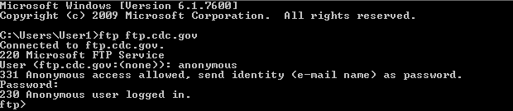

Notice that the C:\> prompt has been replaced with the ftp> prompt. Type **ls** to list the files and directories. At the time that this lab was authored, there was a Readme file.

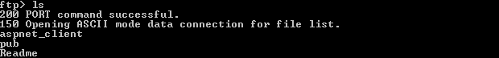

* + 1. At the prompt, type **get Readme**. This downloads the file to your local computer from the anonymous FTP server the Center for Disease Control has setup. The file will be copied into the directory shown in the C:\> prompt (C:\Users\User1 in this case).

**Instructor Note**: The students require a folder where ftp.exe has read and write access for the download and viewing of the Readme file from the ftp site. The folder C:\>Users\User1 is used as an example.

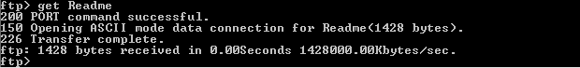

* + 1. Type **quit** to leave FTP and return to the C:\> prompt. Type **more Readme** to see the contents of the document.

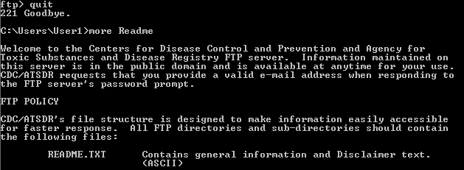

* + 1. What is a drawback of using the FTP from the command line?

____________________________________________________________________________________

It could get tedious to download files this way all the time.

1. Use FTP in a Browser

It is possible to use a browser as an anonymous FTP client.

* + 1. In a browser, type [**ftp://ftp.cdc.gov/**](ftp://ftp.cdc.gov/).

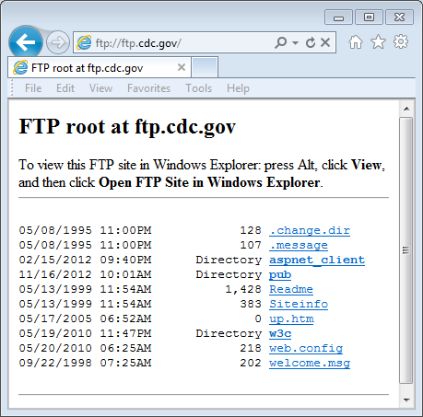

* + 1. Click the **Readme** file.

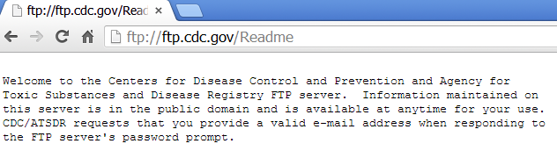

* + 1. Close browser to disconnect the FTP connection.

1. Download an FTP File Using WS_FTP LE (Optional)

In Part 3, you will download a file using WS_FTP LE (a free FTP transfer tool).

**Instructor Note**: Instructors will need to install WS_FTP LE on each student computer. At the time of authoring this was available at: <http://www.wsftple.com/download.aspx>. If this URL has changed, use your favorite search engine to look for “download WS_FTP LE” or “download free FTP”.

* + 1. Start **WS_FTP LE**. If the Ipswitch WS_FTP LE window displays, click **Next** to continue and skip to step c. Otherwise, click the **Open a Remote Connection** link.

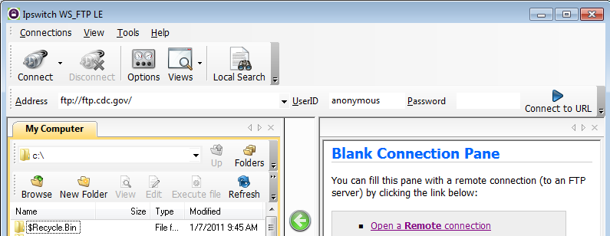

* + 1. Click **Create Site…**.

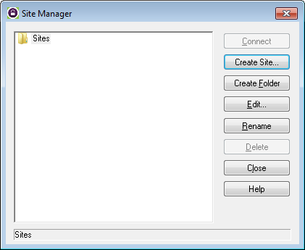

* + 1. In the **Site Name** field, type **Center for Disease Control** and click **Next** to continue.

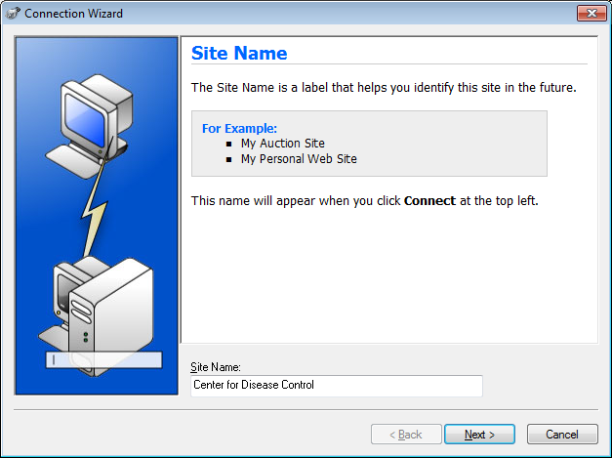

* + 1. Click the **Connection Type** drop-down list, select **FTP** (the default connection type), and click **Next**.

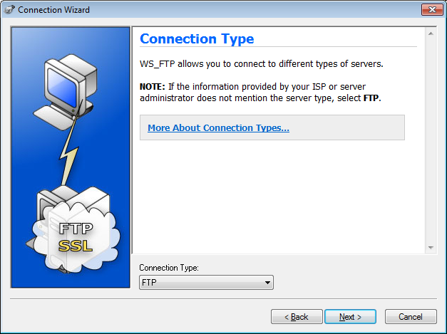

* + 1. In the **Server Address** field, type [**ftp.cdc.gov**](ftp://ftp.cdc.gov),and click **Next**.

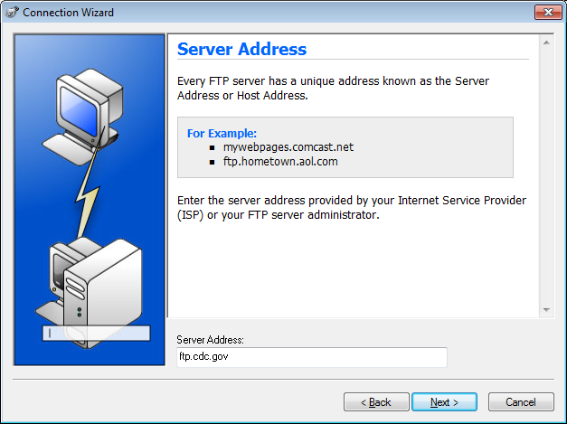

* + 1. In the **User Name** field, type **anonymous**, and leave the password field blank. Click **Next**.

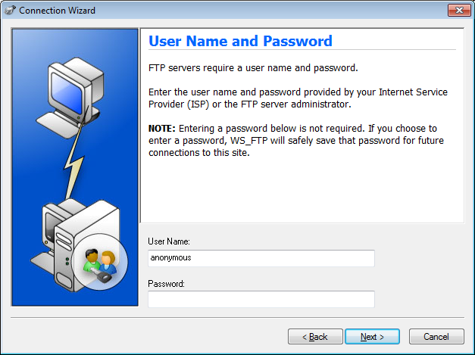

* + 1. Click **Finish**.

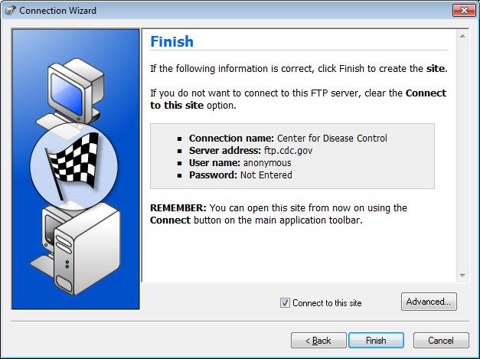

* + 1. When the Login Information Missing dialog box displays, click **OK**. Do not type a password in the **Password** field.

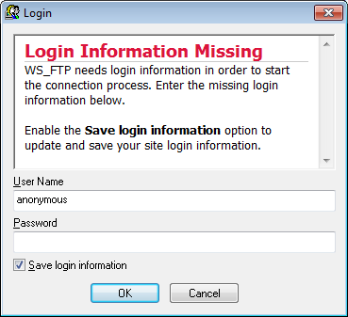

* + 1. You are now anonymously connected to the Center for Disease Control FTP site.

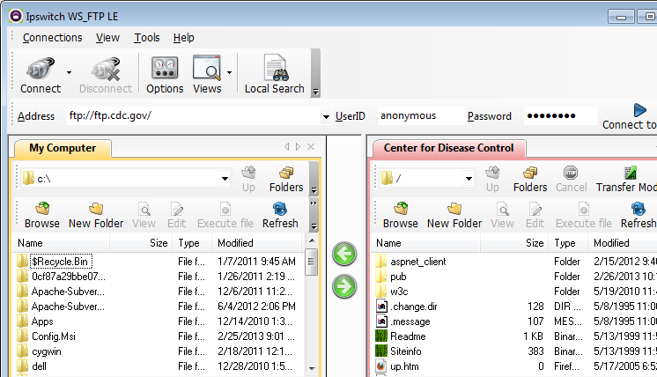

* + 1. On the WS_FTP LE toolbar menu under My Computer, click **New Folder** to create a folder on your local **C:\** drive.
    2. In the Make Directory dialog box name the folder as **CDC** and click **OK**.

**Note**: If the folder already exists, you can use the same folder or create another folder with a different name. If using the same CDC folder, you can replace the existing Readme file with the downloaded Readme file.

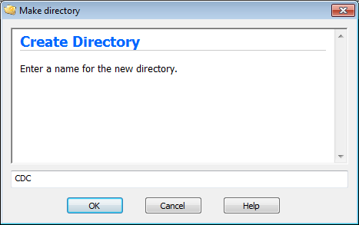

* + 1. After the directory is created, in the **My Computer** tab page, double-click the directory to open it.

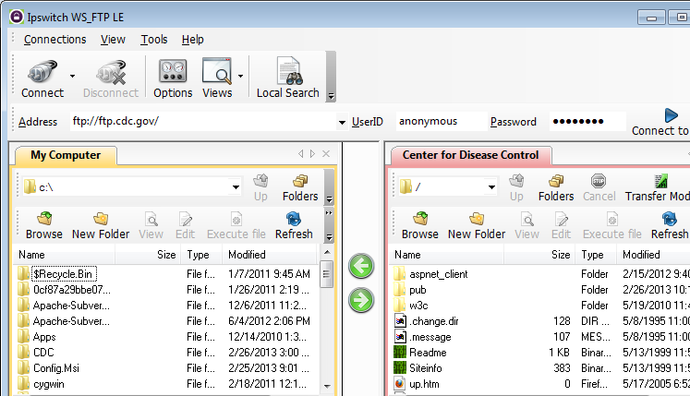

* + 1. Drag the **Readme** file from the right side of the application (the remote CDC FTP server) into the CDC folder on to the local **C:\** drive.

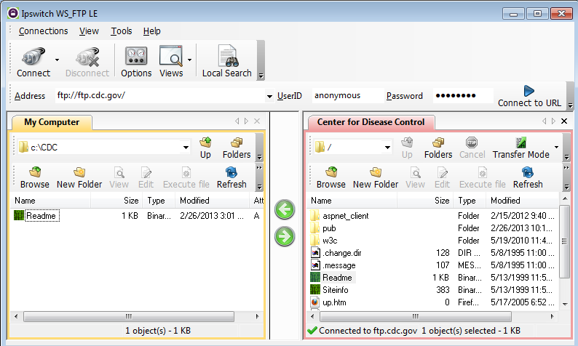

* + 1. Double-click the **Readme** file in the **C:\CDC** folder on your local **C:\** drive. If prompted for an application to open the document, choose any word processing software. You should see a message that looks something like this:

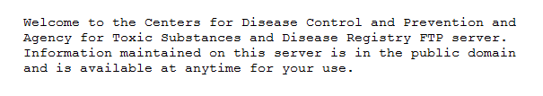

* + 1. Which was easier, using FTP from the **cmd** prompt, or using WS_FTP LE? __________________

After it has been installed, a GUI FTP application such as WS_FTP LE is easier to use, especially if working with a large number of big files.

* + 1. Verify that the Center for Disease Control window is highlighted. Click **Disconnect** to disconnect from the [ftp.cdc.gov](ftp://ftp.cdc.gov) site when finished.
    2. The remote site will be removed from the saved list of FTP sites. In the Ipswitch WS_FTP LE window, click the **Open a Remote Connection** link. Select the **Center for Disease Control** site, and click **Delete** to remove the FTP site. Click **Yes** to confirm the deletion. Click **Close** to exit the Site Manager.
    3. Remove the **C:\CDC** folder.

**Instructor Note**: Please remove C:\CDC or other folders that the students created in this lab.

* + 1. Close Ipswitch WS_FTP_LE.

1. Reflection

List the advantages for using FTP from the command prompt, the browser, and an FTP client, such as WS_FTP LE?

_______________________________________________________________________________________

_______________________________________________________________________________________

_______________________________________________________________________________________

Command line provides quick access, but is more difficult when accessing some features. A browser allows for the quick view of text files. Client software provides the most functionality with expert features, such as batch downloads.